1. **Prerequisites**
2. SSH service is required to be enabled in the Linux side.
3. A Superuser is required to run the migration script.
4. Your Linux server can access to public Azure Web Apps.
5. *PasswordAuthentication* must be enabled for the user to log in via SSH using username and password if it is disabled.
6. *Requiretty* must be disabled for the user to run commmand via SSH with sudo permission if it is enabled.
7. The implementation is based on a modified preview perl script provided by production team. The script can be downloaded from <http://www.movemetothecloud.net/Azure-Apache-Migration-Tool.tar.gz> . Some perl libraries, such as perl LWP HTTPS, are required in Linux side to run the script. Most should be included with your distro. In case it is not, you may need to download and install them manually. By default we don't include this library because it takes OS specific dependencies.

#**Ubuntu**

perl LWP HTTPS can be installed with apt-get:

*sudo apt-get install liblwp-protocol-https-perl*

#**CentOS** 7

perl LWP HTTPS can be installed with yum:

*sudo yum install perl-LWP-Protocol-https*

You may also need to install some additional libraries:

*sudo yum install perl-Digest-MD5*

*sudo yum install perl-Compress-Raw-Zlib*

# **OpenSUSE**

perl LWP HTTPS can be installed with zypper:

*sudo zypper install perl-LWP-Protocol-https*

1. Click Next. 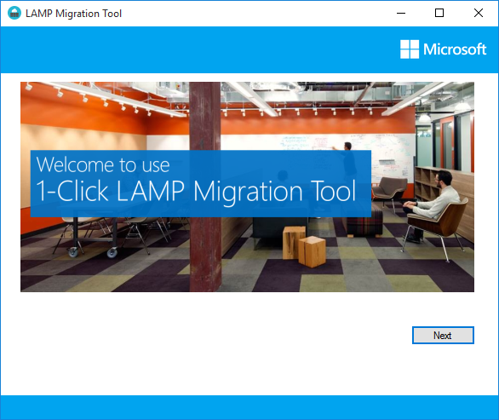
2. Please enter your Linux host admin user name and password.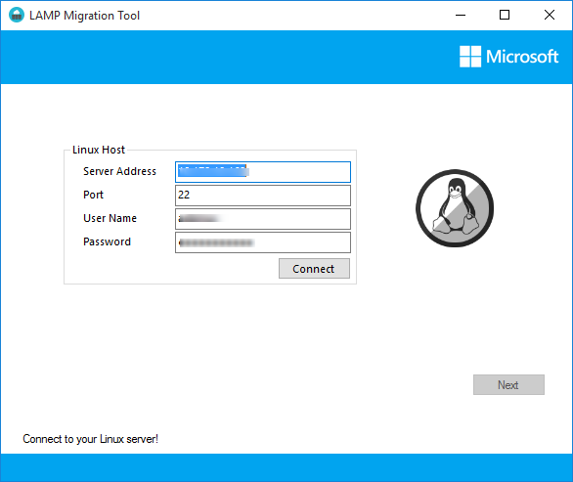
3. Please select your Linux distro type here and filling your Apache configure file.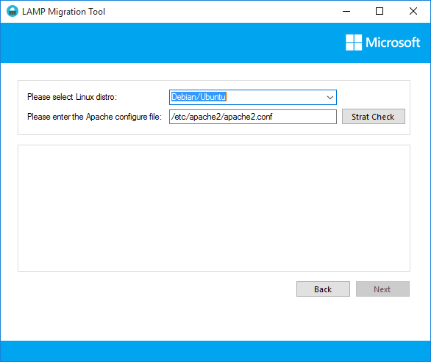
4. Please choose your migration candidate websites.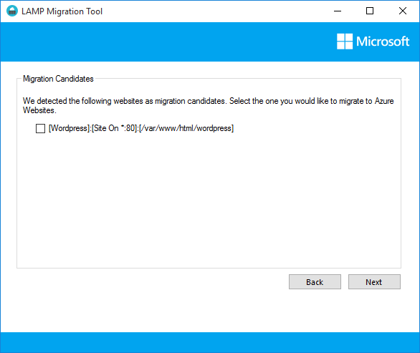
5. If you have created a Web App with MySQL database, please jump to step 6;

If you have a downloaded publishsettings file, please jump to step 7;

1. If you are using classic Azure Portal, please go to http://manage.windowsazure.com and create a **Web App with MySQL** **database.**

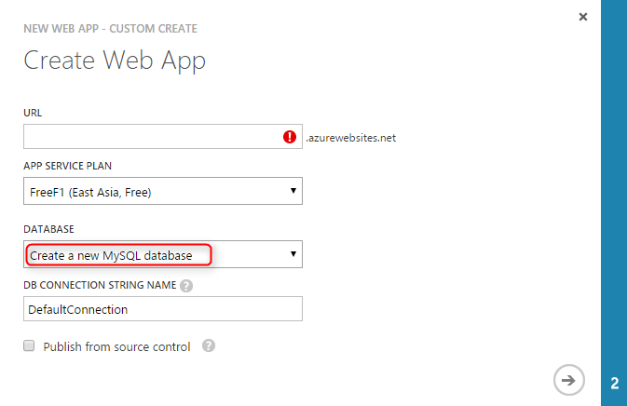

1. If you are using new Azure Portal, please go to <http://portal.azure.com> and create a Web APP + MySQL in Market Place.

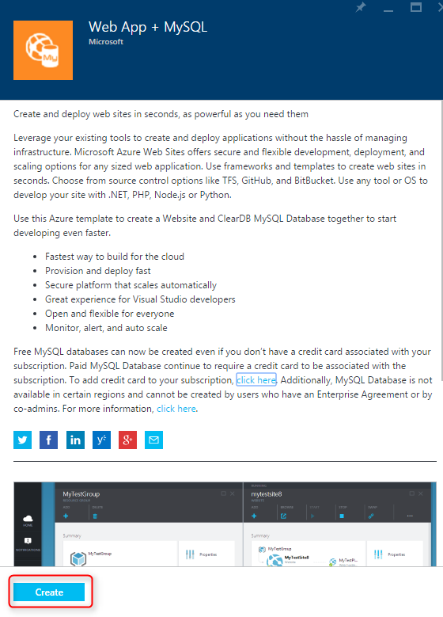

1. 1) If you are using classic Azure portal, please go to your Web App page and download the PublishSettings.

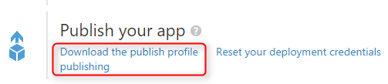

2) If you are using new Azure Portal, please go to your Web Apps blade and download the PublishSettings.

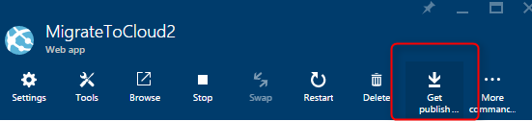

1. Choose the PublishSettings locally. 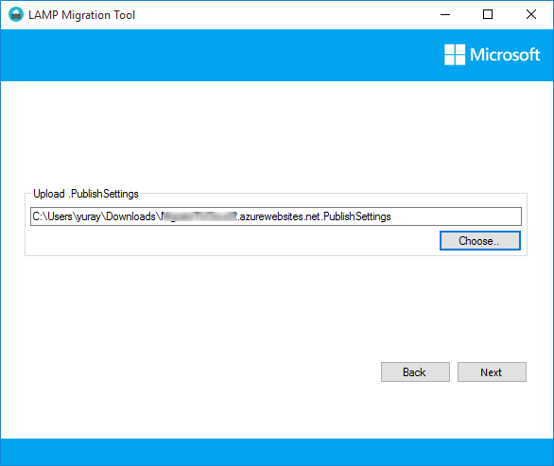
2. Click Start to start migrate. When finished, you can click “Migrate Another One” or Exit. 